**PROJECTDEVELOPMENTPHASE**

**DELIVERY OF SPRINT 2**

|  |  |
| --- | --- |
| Date | 06 November 2022 |
| Team ID | PNT2022TMID30774 |
| Project Name | Project – Personal Assistance for senior citizens who are self-reliant |

**SPRINT II: Development of Web User Interface in NodeRED service of IBM**

**Objectives:**

1. To create a form UI in Node-Red platform to enter the medicine name and time of intake.
2. To send the medicine name at the scheduled time.
3. Complete Web UI flow
4. iv) Deploying Web UI

|  |  |  |  |  |  |  |
| --- | --- | --- | --- | --- | --- | --- |
| **Sprint** | **Functional reruirement(Epic)** | **User story no** | **User story /Task** | **Story points** | **Priority** | **Team Members** |
| Sprint-1 | Registration:  Creation of IBM services like NodeRED,cloudant DB,TTs service and design of IoT system | USN-1 | As a user,I should login into my IBM cloud account | 2 | High | S.kavitha.  M.Gayathri |
| Sprint-2 | Web UI:  Creating web UI using node-red and connect it to IBM cloudant db | USN-2 | As a user ,I should be able to feed the medicine name and intake time in the web UI | 2 | High | S.Durgadevi,  S.Abitha |
| Sprint-3 | Software implementation:  Developing Pyrhon code to retrieve data from cloudant db to send that data to IoT device at the appropriate time | USN-3 | As a user,I should be able to send the medicine name to the IoT device at the scheduled time | 2 | High | A.Bhuvaneshwari,  S.Kavitha |
| Sprint-4 | Hardware implementation:  Converting the data received from cloud as voice using IBM Text to Speech service | USN-4 | As a user,I must be able to hear the medicine name which is to be taken at the appropriate time. | 2 | High | M.Gayathri,  S.Durgadevi  S.Abitha |

**i)Creating a form in Node-Red to enter medicine details:**

* Web UI can be created by using form UI from Node-Red Dashboard
* The Dashboard can be installed from node-red palette
* The medicine name,intake time and day is entered in the form
* The medicine details are wired and stored to the IBM cloudant db database with the help of a function.

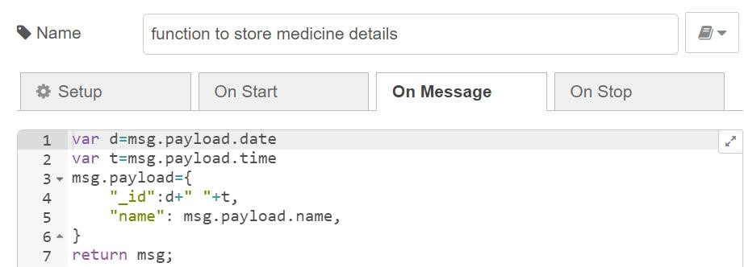

* The below function is used to reset the form after a delay to add more medicine details

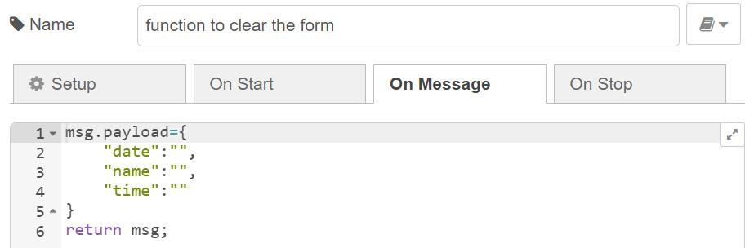

* Node-Red Flow to create a form

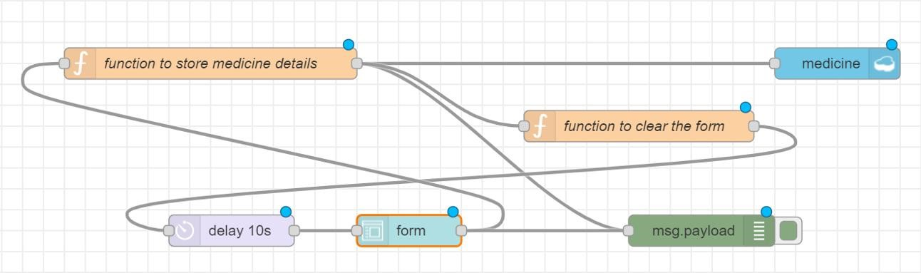

* Web User Interface for entering medicine details

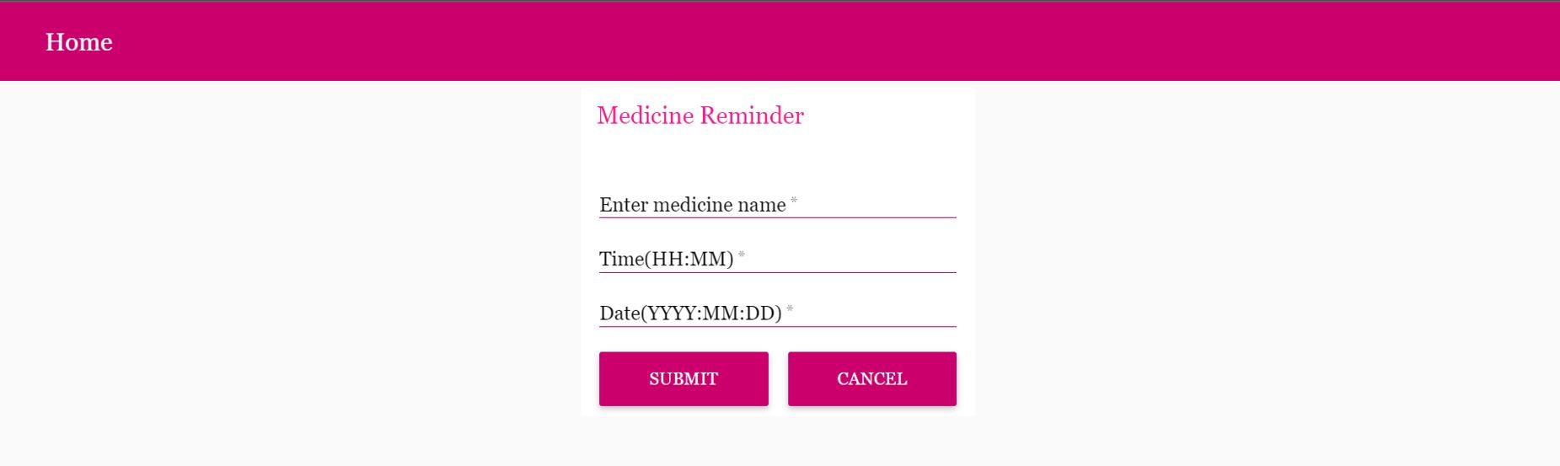

**ii) Sending the medicine name at the appropriate time:**

* A function is created to compare the present time with the scheduled time.
* The function to get the present time is shown below.

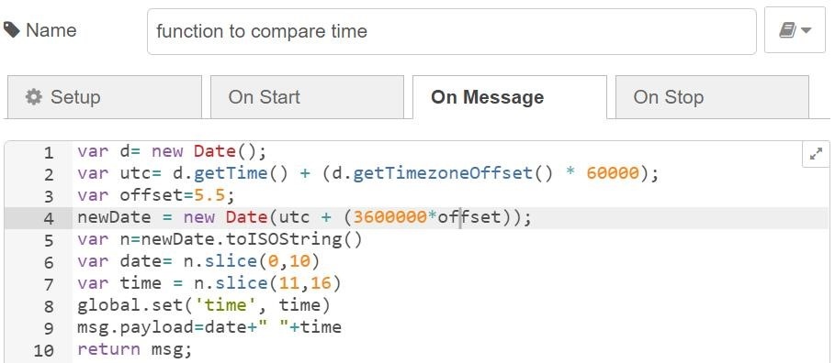

* After obtaining the present time, cloudant node is connected to the function in order search the scheduled time by _id
* The cloudant node is connected to the IBM cloudant database.
* If the present time and scheduled time in the database matches, then the name of the medicine will be sent to the IoT device using switch node and a function following that node

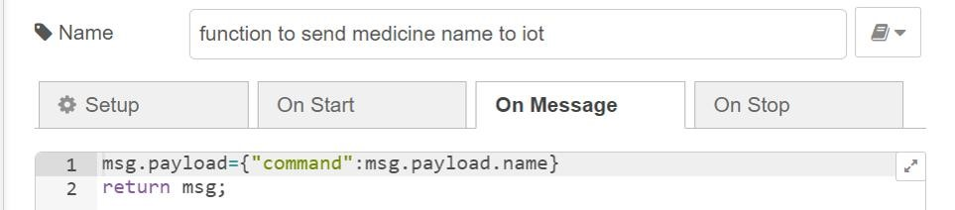

* Overall node flow for sending the meicine name to IoT device.

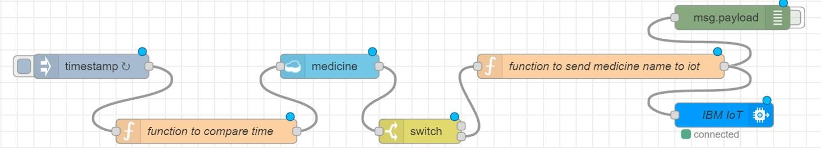

**iii)Complete Web UI flow:**

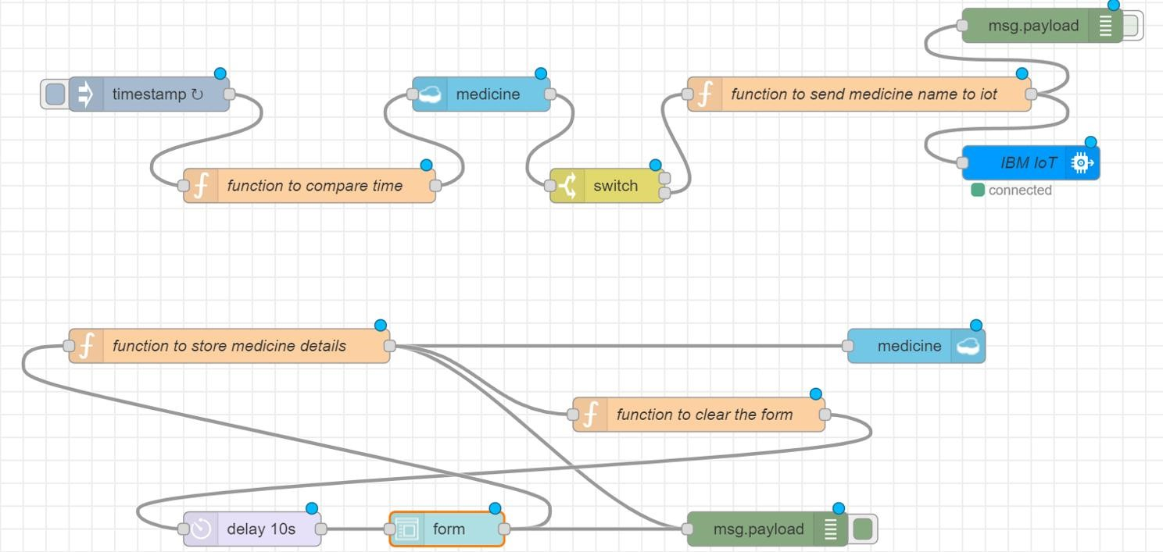

**iv)Deploying Web UI:**

The debug window in Node-Red depicts the medicine details.

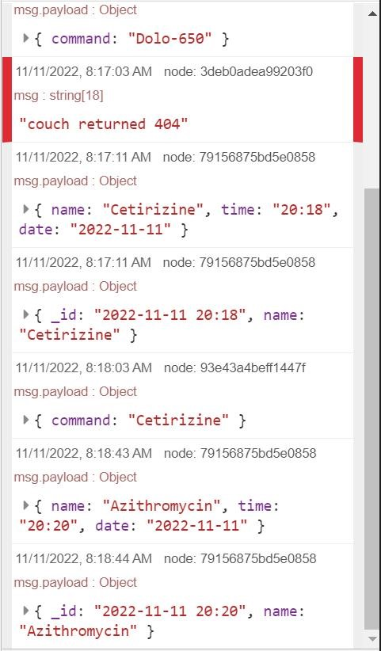

* The following image shows the details of the medicine which is stored in the cloudant db under the medicine database.

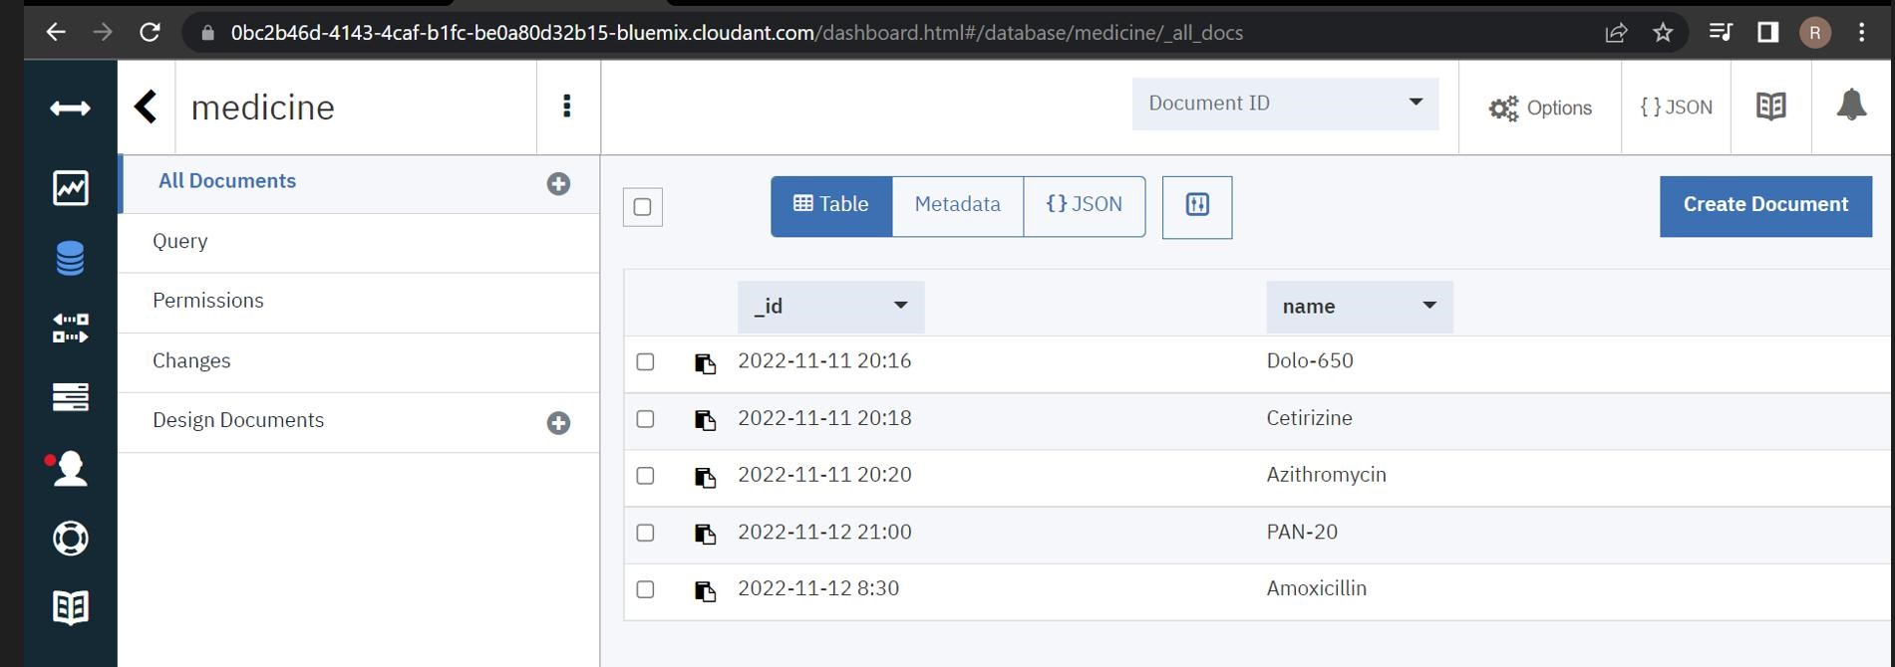

* The following image shows the details of the medicine in the medicine database in JSON format

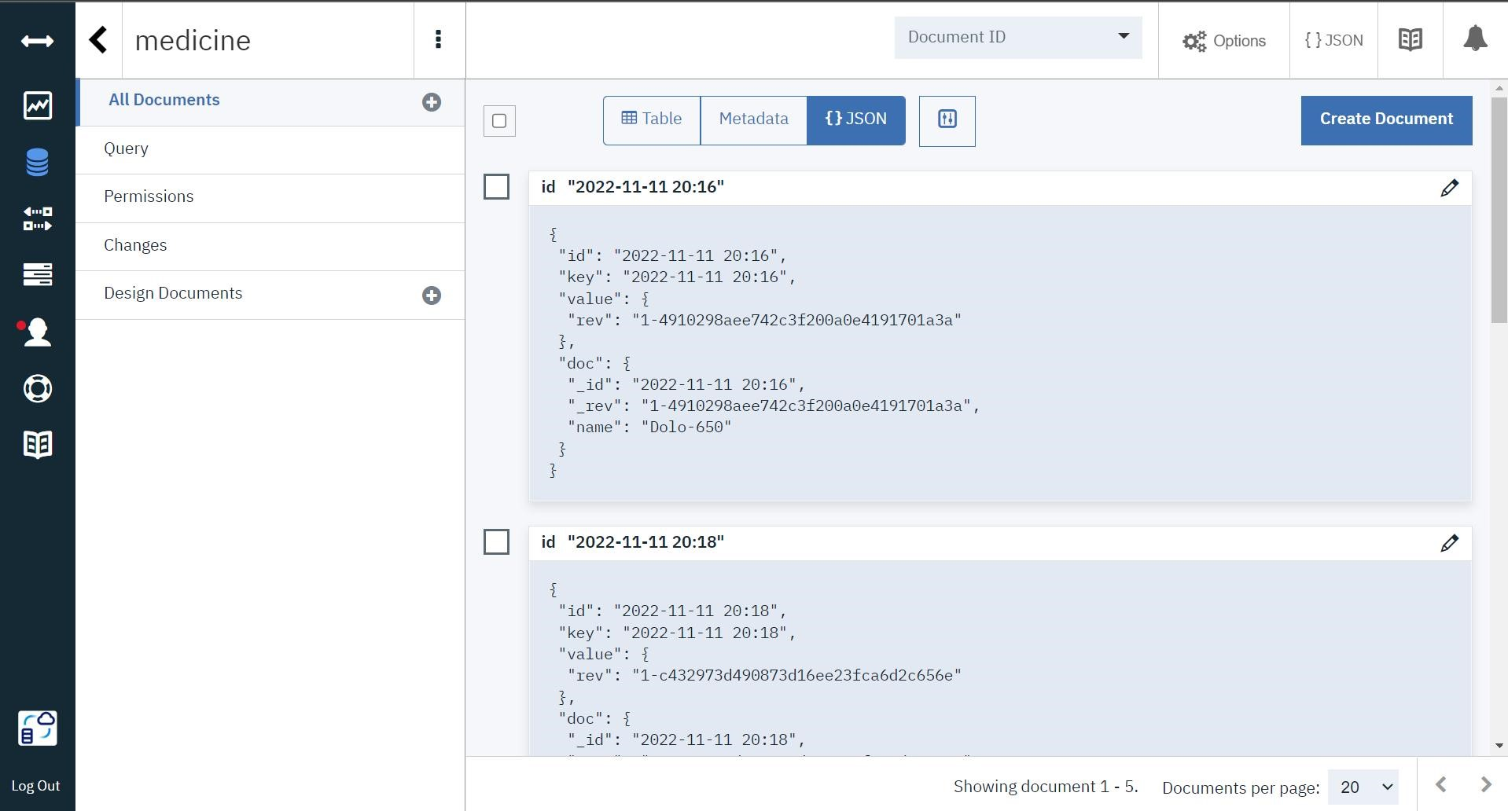

* The medicine reminder operation is depicted below:
  + The medicine name Cetirizine and it’s intake time 20:18 and date 11.11.2022 is stored in the database.

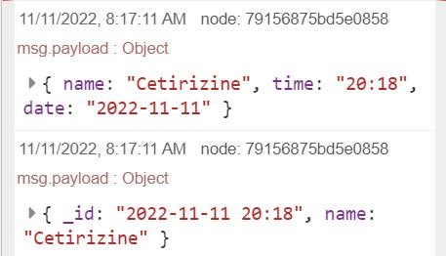

* + When it’s time to take the medicine, the medicine name is sent as a command to the IoT device.



